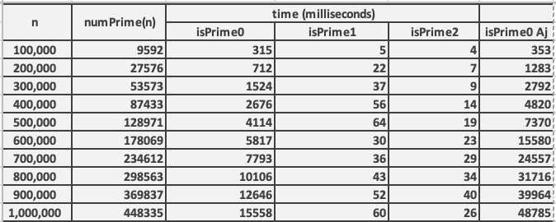Algorithm Time Analysis

my isPrime0 function exhibits a calm increasing trend, suggesting a relatively stable and consistent performance as the input value increases. On the other hand, Ajarn’s isPrime0 function shows a sharp increase in computation time around n = 500,000 continuing to rise nearly up to 50,000 milliseconds.

Different computers can have varying processing power, memory, and other factors that can influence the execution speed of programs. In this case, the observed difference in the increasing trend and computation time could be attributed to the disparities in the computational capabilities of the two machines.

Therefore, the performance discrepancy between the two isPrime0 functions is likely a result of differences in the underlying hardware or system configurations of the respective computers on which they are executed.